|  |  |  |  |  |  |
| --- | --- | --- | --- | --- | --- |
| **Module No:** | 1 | **IU No:** | 2 | **Exercise No.** | 2 |

**Name : Wildan Luqmanul Hakim  
Code : BDSE04-0322/STTB**

|  |  |
| --- | --- |
| **Lab Assessment Statement** | **Assignment 2 - Build React JS Frontend Application**  **Referring to Assignment-1's Project Scenario,**  The scope of this assignment is to develop a frontend for ‘XYZ Cars Pte Ltd’ as a React developer to develop a Used Car Sales portal.  These are the steps provided to build an API.   1. Install Node JS. 2. Create React Application using **npx creact-react-app [project name]** command. 3. Run Application using **npm start** command. 4. Create Service to fetch the data from API. 5. Create methods to make HTTP REST call via Axios. 6. Create the required components to display the data coming from services. 7. Implement React Router to configure routing links.   **Provide the source code of developed application.**  **Provide screen capture of final result pages for API testing.** |
| **Technical Environment** | - REST API, React JS |
| **Guidelines** | - |
| **Duration** | 120 mins |

1. Install Node JS.

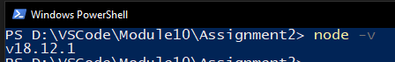

1. Create React Application using **npx creact-react-app [project name]** command.

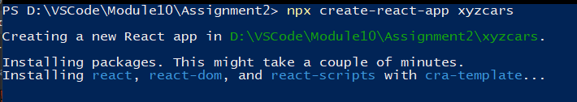

1. Run Application using **npm start** command.

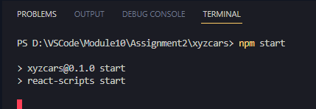

1. Create Service to fetch the data from API.
2. Create methods to make HTTP REST call via Axios.

**Register (FormRegister.js)  
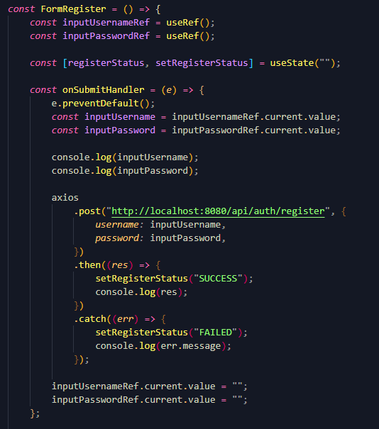**

**Login (FormLogin.js)  
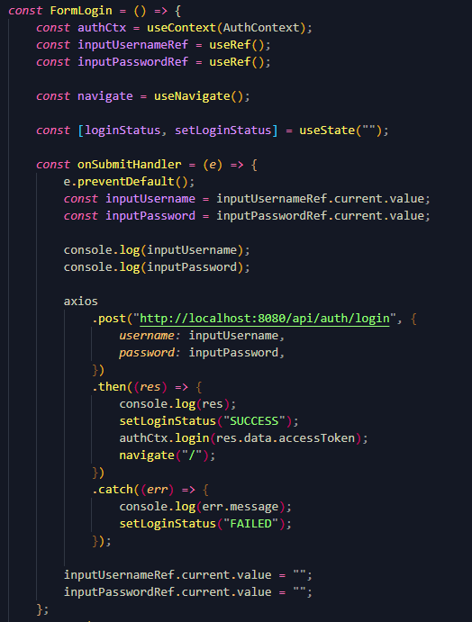**

**Get List Car (car-service.js)  
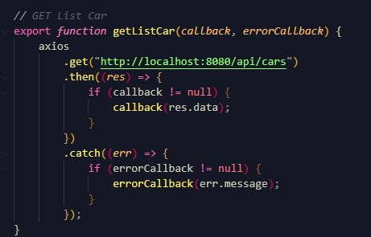**

**Get Car Detail (car-service.js)  
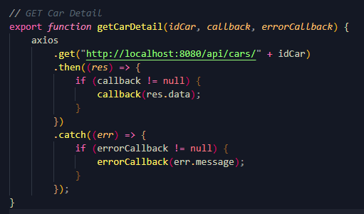**

**Search by Keyword (car-service.js)  
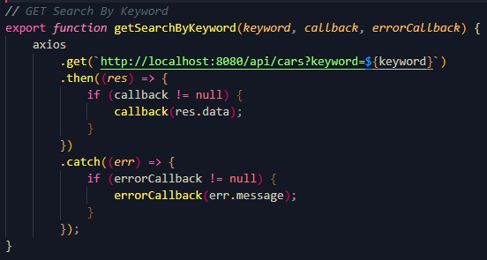**

**Search by Price (car-service.js)**

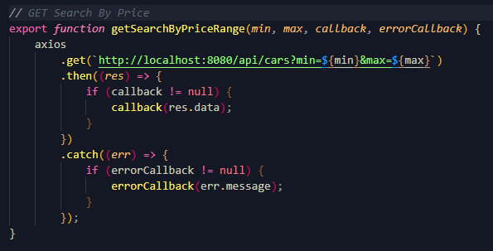

1. Create the required components to display the data coming from services.

**Home Page (List Car)**

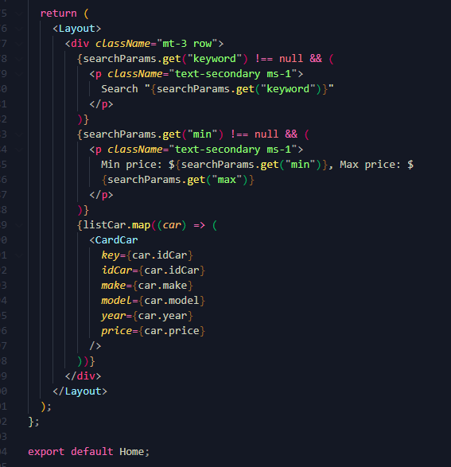

**Card Car (List Car)  
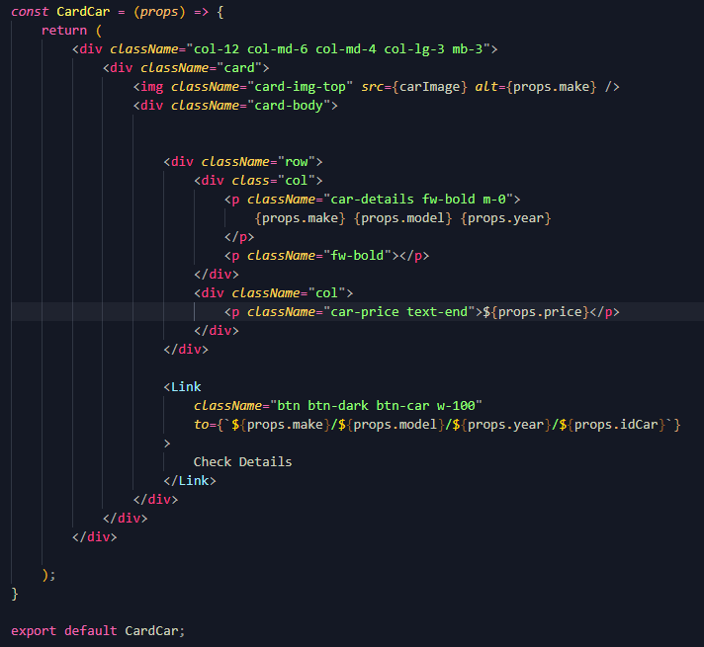**

**Car Detail**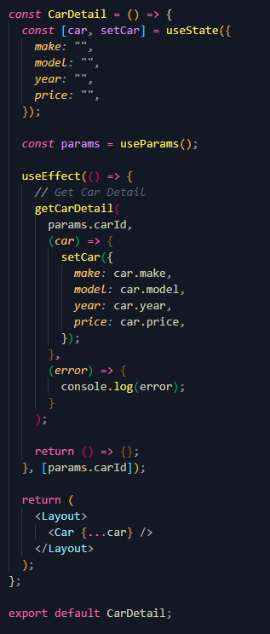

1. Implement React Router to configure routing links.  
   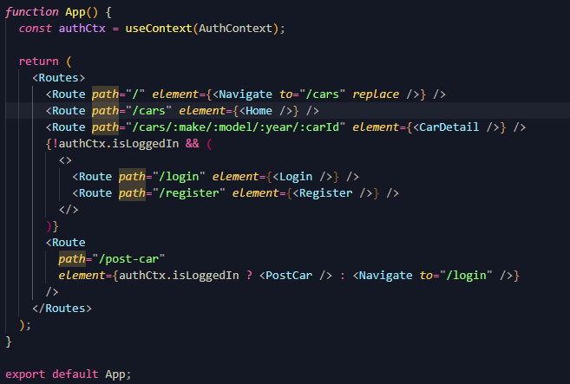
2. Screenshot  
   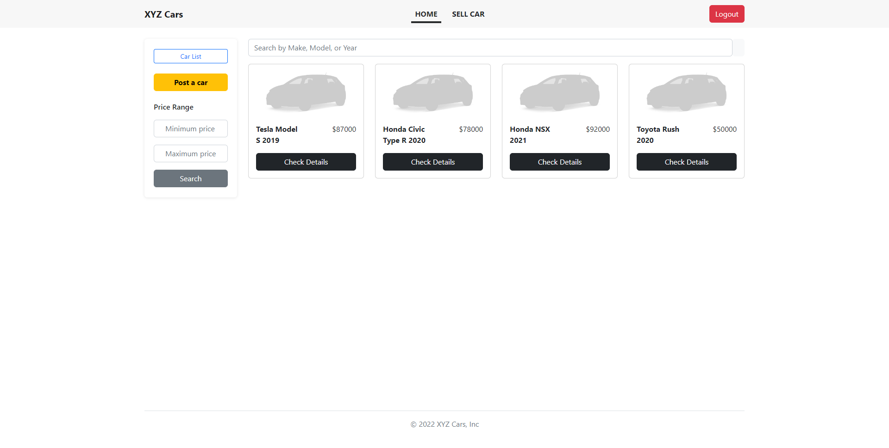

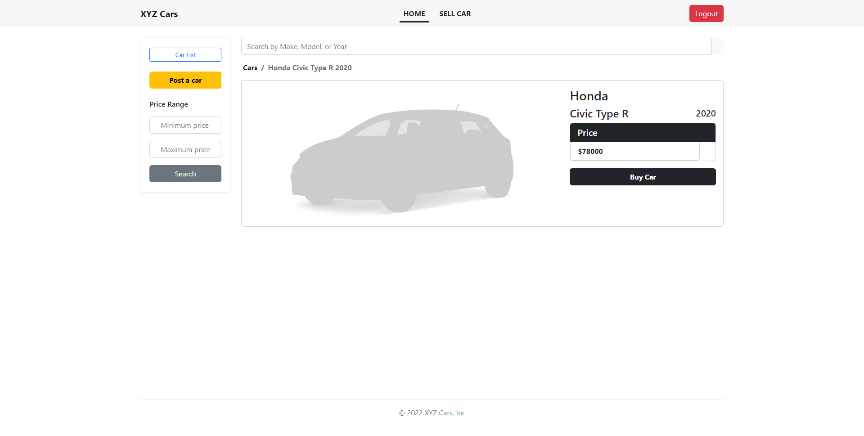

**Source Code**

